The purpose of this program is to convert British Pounds (GBP) to Euros (EUR) and Euros to British Pounds. The software was created for a local travel agent so that they can quickly calculate currency conversions for customers. The program uses a simple graphical user interface to allow the user to enter an amount and view the converted result.

The user interface was created using Windows Forms. The interface includes text boxes where the user can enter an amount in GBP or EUR. Labels are used to identify each input and output field clearly. Buttons are included to perform the currency conversion and to clear the input fields. The interface was designed to be simple and easy to use, allowing travel agents to quickly perform conversions without confusion.
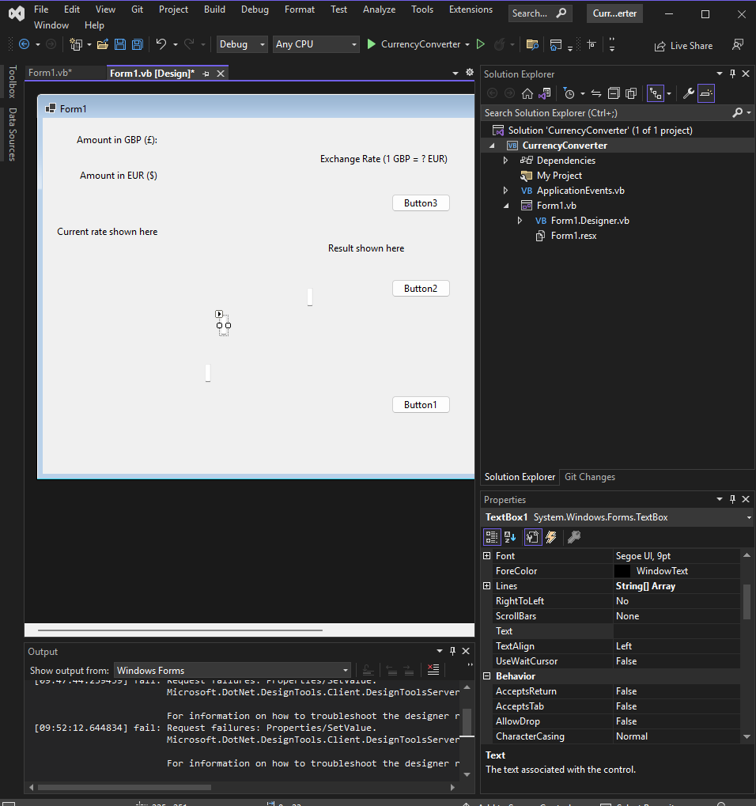
The program was developed using Visual Basic. Local variables are used to store the values entered by the user and the exchange rate used for the currency conversion. An assignment is used to store the value from the input text box into a variable. A sequence of instructions is used to read the input value, perform the conversion calculation and display the result in the output label. Input validation is also used to check that the user enters numeric values before performing the conversion. 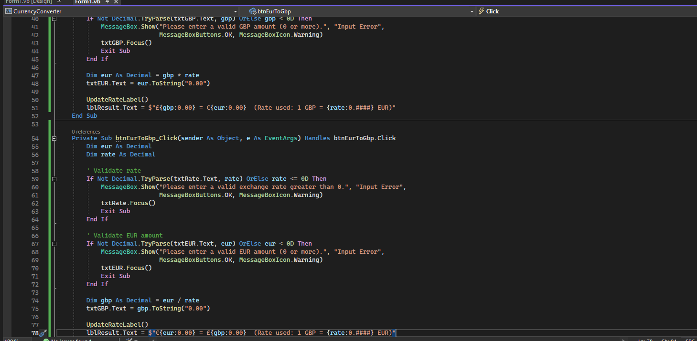

A test plan was created to ensure that the program works correctly under different conditions. The program was tested using normal data, abnormal data and extreme data. This ensures that the software meets the requirements of the travel agent and works correctly with different types of user input.

No.# | Purpose of Testing | Test Data | Expected Result | Actual Results | Comments
1. | To check if a value entered in British pounds is converted successfully to Euro | Normal data:  £157.85 | 179.94 | 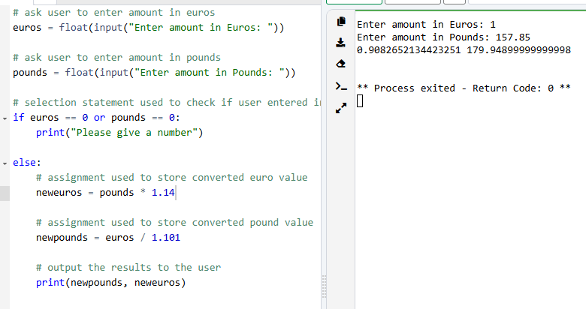 | The program works as required
2. | To check if a value entered in British pounds is converted successfully to Euro | Abnormal data:  £23JJ.78 | I except an invalid data message requesting me to enter a valid data | 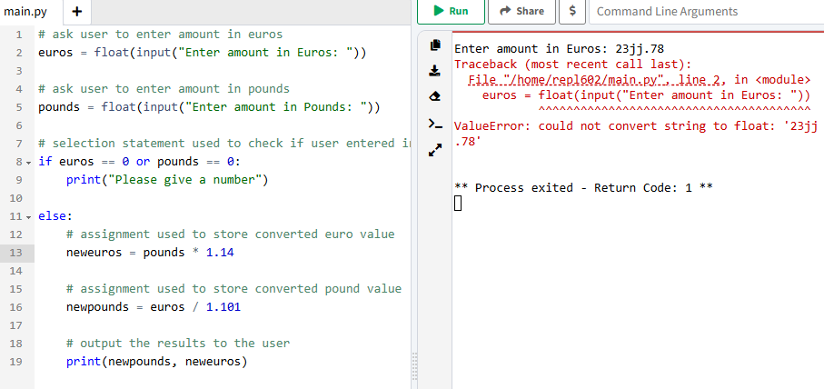 | The program works as required
3. | To check if a value entered in British pounds is converted successfully to Euro | Extreme data:  £876543323223 | The program to convert the large extreme number to Euro | 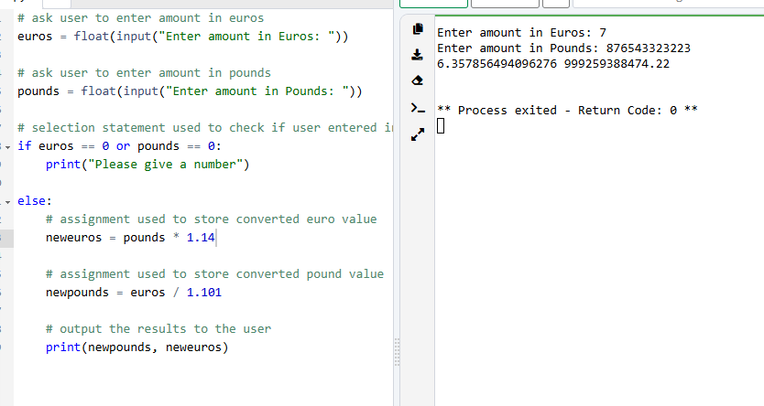 | Code runs successfully
4. zero value | Purpose of testing: To check if a value of zero GBP is converted correctly | £0 | It should ask for  A number | 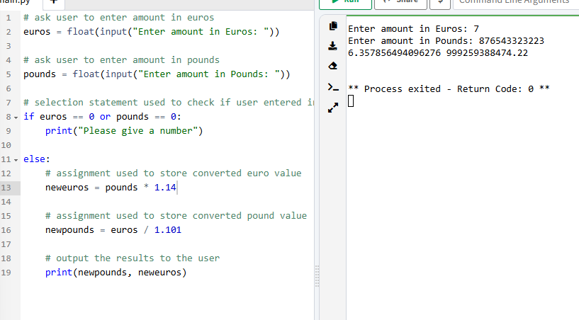 | Code runs successfully
5. | Purpose of testing: To check how the program handles negative values | £-45 | The program should correctly convert the value from GBP to EUR." | 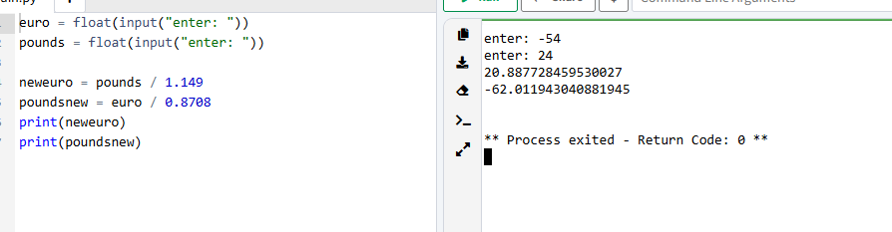 | Code runs successfully
6. | Purpose of testing: To check input validation for non-numeric data | ery | Error message | 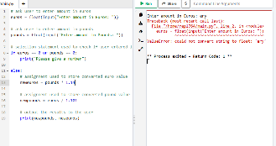 | Code didn’t work as expected
7. | Purpose of testing: To check how the program handles no input | Nothing | Error message | 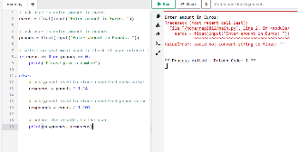 | The program produced an error because the input was not numeric. This shows input validation needs improvement.
8. | Purpose of testing: To check if symbols are rejected | %%%% | Error message | 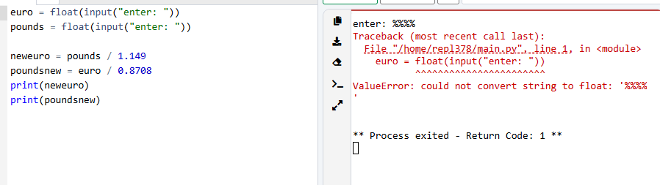 | The program produced an error because the input was not numeric. This shows input validation needs improvement.
9. | Purpose of testing: To check if the program handles long decimal numbers | 31.9876543 | The program should correctly convert the value from GBP to EUR." | 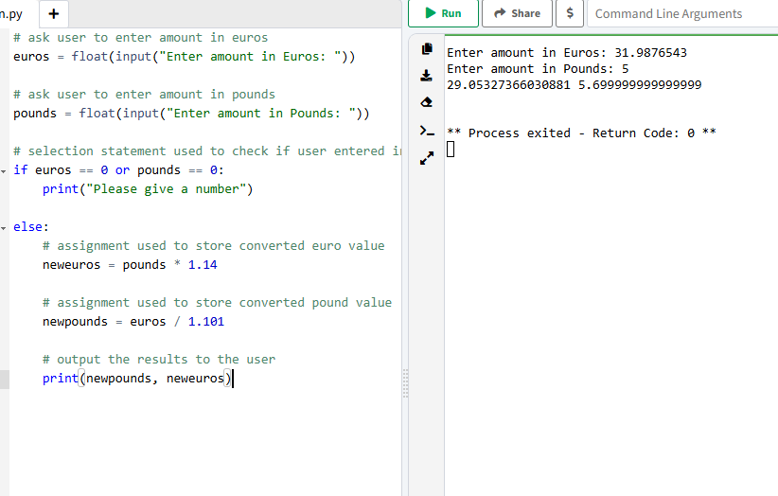 | Works as expected
10. | Purpose of testing: check if the clear buttons are working | C or q to quit | Clear it | 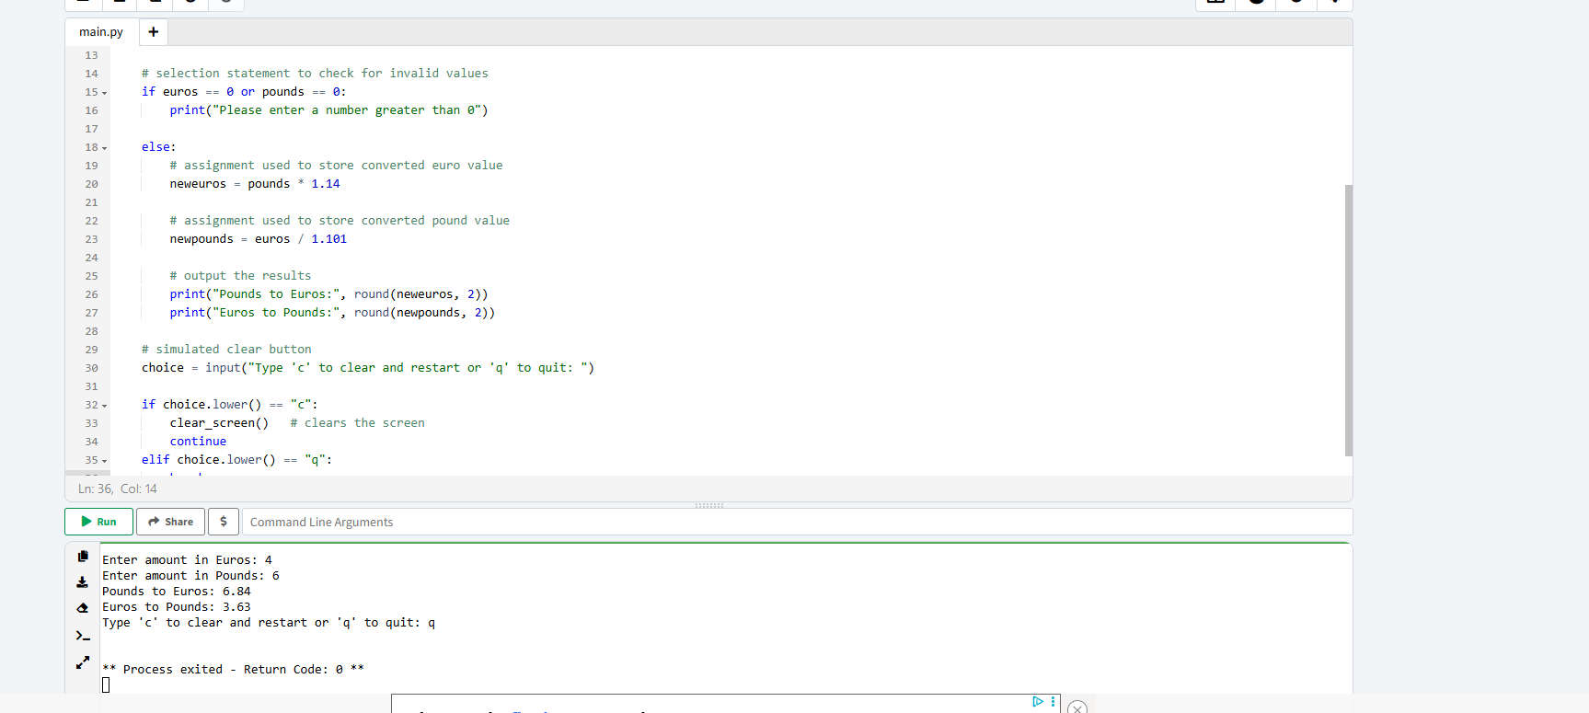 | Works as expected
The testing results show that the program works correctly for most inputs. Normal data successfully converts GBP to EUR using the exchange rate. Extreme values and long decimal numbers were also handled correctly by the program. However, some tests revealed that input validation could be improved when users enter non-numeric characters or leave the input blank.

During the development process, several improvements were made to the program. Initially, the program did not handle non-numeric input correctly. Input validation was added to check that the value entered by the user is numeric before performing the calculation. Additional comments were also added to the code to explain how the program works and improve readability.
The code was written with maintainability in mind by including comments explaining key sections of the program. This makes it easier for future developers to understand and modify the code if needed. The program is portable as it can run on any computer that supports the .NET Framework. The simple user interface improves usability as travel agents can quickly perform conversions without needing technical knowledge.
Overall, the software solution successfully meets the requirements of the travel agent. The program allows users to convert currencies quickly and accurately using a simple graphical interface. Testing confirmed that the program works correctly for most input values, and improvements were made during development to increase reliability and usability.

